Fashion-Boots

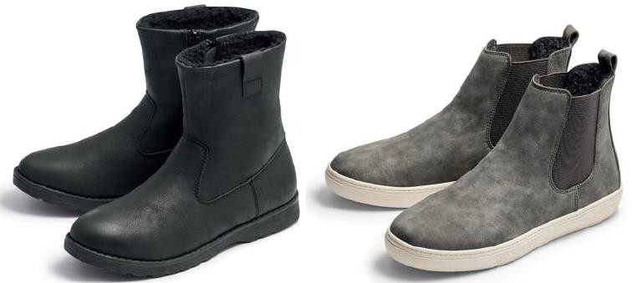
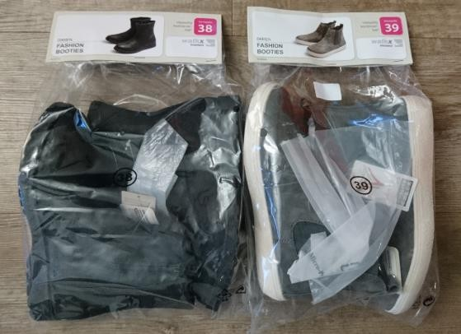

description: | - Fashion-Boots ideal fort he cold season  - upper made of easy-care PU  - interior and insole made of warming textile  - outsole made of TPR
sorting 1: | model / size 37 38 39 40 41  black grey 1 2 3 2 1 9 pairs  grau 1 1 2 1 1 6 pairs  TOTAL 2 3 5 3 2 15 pairs  qty: 4.100 pairs  brand: walkx women  carton labeling: FASHION BOOTIES TIL DAMER 1596-015  range factorr: 12 cartons / palette (3 layers à 4 cartons)  Price : 3,45 € per Pairs
sorting 2: | model / size 37 38 39 40 41  grey 2 2 2 2 2 10 pairs  TOTAL 2 2 2 2 2 10 pairs  qty: 7.100 pairs  brand: walkx women  carton labeling: DAMESLAARZEN BOTTES POUR DAMES 9701-010  range factor: 18 cartons / palette (3 layers à 6 cartons)  Price : 2,95 € per Pairs
Retail price ALDI : | 14,99 €

I

